**Gaussian Discriminant Analysis**

Author(s): Anne Kunstmann (6651481), Alina Munir (7251819)

**Parameters:**

In our GDA Training we extracted each image into 6 features i.e. Ravg, Gavg, Bavg, Rmin, Gmin, Bmin. Average and minimum values of Red, Green and Blue in every image of 24*24*3 were considered to be the primary features of an image.

Our model’s GDA Parameters are shown below (fig. 1): a

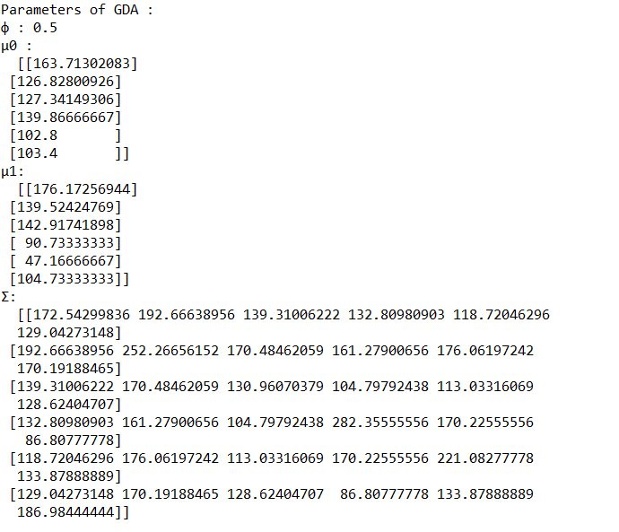

fig. 1

**Analysis:**

We trained our model with 30 positive images and 30 negative images and calculated the parameters (φ,µ0,µ1,Σ). We tested our model with all 60 examples to see the correctness in class prediction. We found that one example from negative class was incorrectly assigned to class 1 (positive class). Below shown (fig. 2) is a bar graph of both correct and wrong predictions:

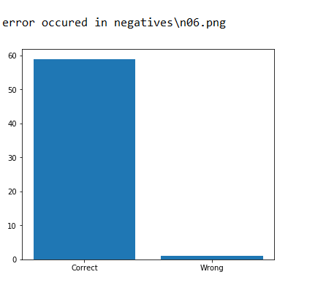

fig. 2

**Conclusion:**

Our system correctly predicted 59 tested examples out of 60, but misclassified 1 example due to higher values of Bavg and Bmin and lower values of Gavg and Gmin for negative\n06.png file in comparison to these features of other negative examples. It is better to use some other features for our images too, than just color concentrations in order to have better prediction rates.

Classification via linear regressing was way easier because we did not have to extract features like we do here in this image classification in GDA. Maybe for a bigger scale or more complex dataset we should use Convolutional Neural Networks techniques to extract local features from input images and classify the testing examples based on those learnt features.